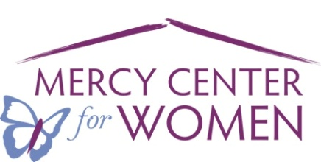 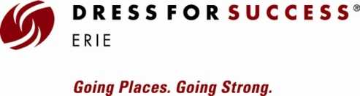

**2018 Purse & Pearl Luncheon Sponsorship Form**

Name: ______________________________________________________________________

Business/Organization: _________________________________________________________

Address: _____________________________________________________________________

City: _______________________________ State: _____________________ Zip: ___________

Phone: _______-_________________ E-mail Address: _________________________________

**Sponsorship Levels and Gratitudes**

**$3,500 ~ “Success” Sponsor**

One table for ten guests

**\***Your Name on the invitation

**Lead logo** on our Websites

and Event material

**$2,500 ~ Mabe’ Pearl**

One table for ten guests

**\***Your Name on the invitation

Logo on our Websites

and Event material

**$1,500 ~South Sea Pearl**

One table for ten guests

**\***Your Name on the invitation

Logo on our Websites

and Event material

**$1,000 ~ Cultured Pearl**

One table for ten guests

**\***Your Name on the invitation and our Websites

Logo on Event material

**\***Your name will be present on the invitation **(*if payment is received by March 16thdue to printing).** All sponsorships will be recognized in the power point presentation at the event. All sponsorship levels cover attendance for our clients.

___________________________________________________________________________________________________________

Please enclose this form and make your check payable to: **Mercy Center for Women**

**Total amount enclosed $ _____________________________**

**All payments must be received by April 30th, 2018**

Mail to: Mercy Center for Women

“Purse & Pearl” Sponsorship

1039 East 27th Street, Erie PA 16504

**Please send your Logo to erie@dressforsuccess.org**

**Contact Jennie Hagerty ~ 455-4577 or Mary Graziano ~ 814-456-0733 if you have any questions**